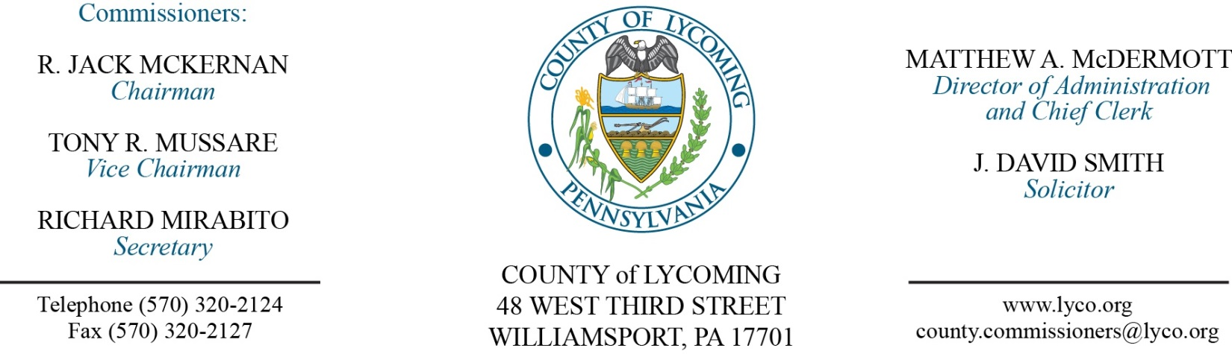
Commissioners’ Meeting Agenda
November 6, 2016

Opening Prayer

Pledge to the Flag

1.0 OPERATIONS

1.1 Convene Commissioners’ meeting.

1.2 Approve the minutes of the previous meetings.

1.3 Receive public comments (agenda items only).

2.0 ACTION ITEMS

2.1 Sale of Real Property on Warrensville Road to Park Home in the amount of $325,000. (Mya Toon)

2.2 Award contract for professional Land Surveyor services to Vassallo Engineering. (Mya Toon)

2.3 Award contract for Bunker Renovation White Deer Golf Course to Signet contingent upon inspection by BCG with contractor. (Mya Toon)

2.4 Award contract for Bunker Sand & Gravel White Deer Golf Course to Synatek. (Mya Toon)

2.5 Approve purchase of irrigation system upgrade and greens head project in the amount of $142,226.04,000.00 from Atlantic Irrigation Specialties, Inc. for White Deer Golf Course. (Mya Toon)

2.6 Approve amendment to professional service agreement with Harry Vanvliet for Investigative Services for the PD’s office. (Mya Toon)

2.7 Approve 2016 PHARE conditional award of funds from PHFA in the amount of $3.1 million. (Kim Wheeler)

2.8 Approve agreement with Sungard for EFinance upgrade to 5.1. (Karl Demi)

2.9 Approve software license agreement with Teleosoft for court scheduling software in the amount of $56,320. (Karl Demi)

2.10 Approve maintenance agreement with Teleosoft for court scheduling software in the amount of $11,264. (Karl Demi)

2.11 Approve quote from Deacon Equipment Company, Inc., for the replacement in the amount of $17,742.03. (Jason Yorks)

2.12 Accept Human Resources report through October 31, 2016. (Roxanne Grieco)

2.13 Approve the following personnel actions: (Roxanne Grieco)
Domestic Relations – Erika N. Young as full time replacement Clerk I – Pay grade 2 - $11.67/hour effective 11/7/16.

5.0 REPORTS/INFORMATION ITEMS

5.1 LCRMS is requesting bids for Consumable Energy Products. (Jason Yorks)

5.2 LCRMS is requesting bids for 4 Used Dry Cargo Van Trailers (2nd request). (Jason Yorks)

6.0 COMMISSIONER COMMENT:

7.0 PUBLIC COMMENT:

8.0 NEXT REGULARLY SCHEDULED MEETING: Planning Session on Tuesday, November 15, 2016. No meetings November 8 & 10, 2016.

9.0 ADJOURN COMMISSIONERS’ MEETING.

